### **HTML CSS:**

* HTML stands for:
  + **A. HyperText Markup Language**
  + B. High-Level Text Markup Language
  + C. HyperTransfer Markup Language
  + D. HyperLink and Text Markup Language
* Which HTML tag is used for creating an ordered list?
  + A. <ul>
  + **B. <ol>**
  + C. <li>
  + D. <dl>
* In CSS, which property is used to change the text color of an element?
  + A. text-color
  + **B. color**
  + C. font-color
  + D. text-style
* What does the CSS property margin: 10px 20px 15px 5px; represent?
  + **A. Top, Right, Bottom, Left margins**
  + B. Left, Bottom, Right, Top margins
  + C. Top and Bottom margins only
  + D. Left and Right margins only
* Which HTML tag is used for creating a hyperlink?
  + A. <link>
  + **B. <a>**
  + C. <hlink>
  + D. <url>
* The CSS property display: inline-block; is used for:
  + A. Displaying elements as a block
  + **B. Displaying elements inline with a block layout**
  + C. Displaying elements inline with some block-level features
  + D. Hiding elements from the display
* Which HTML tag is used for defining the structure of an HTML document, such as headings and paragraphs?
  + A. <section>
  + **B. <body>**
  + C. <header>
  + D. <main>
* In CSS, the float property is used for:
  + A. Adding floating elements to the page
  + B. Floating text within a paragraph
  + C. Creating rounded corners
  + **D. Positioning an element to the left or right of its containing element**
* Which CSS selector is used to select elements with a specific class?
  + A. #class
  + B. **.class**
  + C. class{}
  + D. classSelector
* What does the HTML attribute alt in the <img> tag represent?
  + **A. Alternative text for the image**
  + B. Alignment of the image
  + C. Altitude of the image
  + D. Animation level of the image

### **HTML MCQs:**

* What is the purpose of the HTML <meta> tag?
  + A. Define a new meta keyword
  + **B. Provide metadata about the HTML document**
  + C. Create a new HTML section
  + D. Define a media element
* Which HTML tag is used for creating a table?
  + **A. <table>**
  + B. <tab>
  + C. <tbl>
  + D. <tr>
* In HTML, which attribute is used to specify the URL of an external stylesheet file?
  + A. src
  + **B. link**
  + C. href
  + D. style
* Which HTML tag is used for creating an unordered list?
  + **A. <ul>**
  + B. <ol>
  + C. <li>
  + D. <dl>
* What is the purpose of the HTML <canvas> element?
  + A. Embed audio content
  + B. Embed video content
  + **C. Draw graphics using JavaScript**
  + D. Define a new font style
* Which HTML tag is used for creating a hyperlink to an email address?
  + A. <email>
  + B. <link>
  + C. <mail>
  + **D. <a>**
* In HTML, which tag is used for creating a line break?
  + A. <lb>
  + **B. <br>**
  + C. <break>
  + D. <line>
* What does the HTML attribute colspan represent in a table cell?
  + **A. Column span**
  + B. Color of the cell
  + C. Content spacing
  + D. Cell padding
* Which HTML tag is used for embedding a video on a webpage?
  + **A. <video>**
  + B. <media>
  + C. <embed>
  + D. <play>
* What does the HTML attribute target="_blank" do in a hyperlink?
  + **A. Opens the link in a new tab or window**
  + B. Links to a blank webpage
  + C. Targets a specific element on the same page
  + D. Ignores the hyperlink

### 

* What is the purpose of the CSS property padding?
  + **A. Adds space inside the element's border**
  + B. Adds space outside the element's border
  + C. Sets the element's font size
  + D. Defines the element's background color
* Which CSS property is used for changing the text alignment within an element?
  + **A. text-align**
  + B. line-align
  + C. content-align
  + D. align-text
* In CSS, what does the property position: absolute; do?
  + A. Positions the element relative to its normal position
  + B. Positions the element relative to its parent
  + **C. Removes the element from the document flow**

### 

* Which HTML tag is used for creating a hyperlink to another webpage?
  + A. <link>
  + B. <href>
  + C. <a>
  + **D. <url>**
* What does the HTML attribute alt in the <img> tag represent?
  + **A. Alternative text for the image**
  + B. Alignment of the image
  + C. Altitude of the image
  + D. Animation level of the image
* Which HTML tag is used for creating an ordered list?
  + A. <ul>
  + **B. <ol>**
  + C. <li>
  + D. <dl>
* What does the HTML element <article> represent?
  + A. A navigation menu
  + **B. A standalone piece of content that can be distributed and reused**
  + C. A section of a page
* In HTML, the <figcaption> tag is used in conjunction with which other HTML element?
  + **A. <figure>**
  + B. <caption>
  + C. <img>
  + D. <section>
* Which HTML tag is used for creating a form?
  + **A. <form>**
  + B. <input>
  + C. <label>
  + D. <fieldset>
* What is the purpose of the HTML <aside> element?
  + A. Displaying a sidebar
  + B. Defining a section of navigation links
  + **C. Providing additional information or related content**
  + D. Creating a header for a section
* Which HTML attribute is used to define the character encoding for the document?
  + **A. charset**
  + B. encoding
  + C. type
  + D. character
* In HTML, what does the <mark> element represent?
  + **A. A highlighted text**
  + B. A navigation link
  + C. A code block
  + D. A section of emphasized text
* Which HTML tag is used for creating a horizontal line?
  + A. <line>
  + **B. <hr>**
  + C. <hrule>
  + D. <hline>
* In HTML, what does the <summary> element represent?
  + A. A section of code
  + B. A summary of the page
  + C. A navigation link
  + **D. A summary of details in a <details> element**
* Which HTML tag is used for defining the main content of a document?
  + A. <body>
  + **B. <main>**
  + C. <content>
* What is the purpose of the HTML <abbr> element?
  + **A. Creating an abbreviation or acronym**
  + B. Adding bold text
  + C. Aligning text
  + D. Displaying a block of code
* Which HTML tag is used for creating a drop-down list?
  + **A. <select>**
  + B. <list>
  + C. <dropdown>
  + D. <options>
* What is the purpose of the HTML <footer> element?
  + A. Creating a navigation footer
  + B. Defining a page header
  + C. Providing additional information or links related to the content
  + **D. Displaying a copyright notice**

### 

* In CSS, what does the property margin: 10px 20px 15px 5px; represent?
  + **A. Top, Right, Bottom, Left margins**
  + B. Left, Bottom, Right, Top margins
  + C. Top and Bottom margins only
  + D. Left and Right margins only
* Which CSS property is used for changing the background color of an element?
  + A. background
  + B. color
  + **C. background-color**
  + D. bg-color
* In CSS, what does the property position: relative; do?
  + **A. Positions the element relative to its normal position**
  + B. Positions the element relative to its parent
  + C. Removes the element from the document flow
  + D. Aligns the text within an element
* Which CSS property is used for creating rounded corners?
  + A. corner-radius
  + **B. border-radius**
  + C. round-corner
  + D. corner-style
* In CSS, the max-width property is used for:
  + A. Setting the maximum font size
  + **B. Limiting the maximum width of an element**
  + C. Defining the maximum number of lines
  + D. Controlling the maximum height of an element
* Which CSS property is used for changing the font family of text?
  + A. font-style
  + **B. font-family**
  + C. text-font
  + D. font-type
* In CSS, the float property is used for:
  + A. Adding floating elements to the page
  + B. Floating text within a paragraph
  + C. Creating rounded corners
  + **D. Positioning an element to the left or right of its containing element**
* What does the CSS property display: inline-block; do?
  + A. Displays elements as a block
  + B. Displays elements inline with a block layout
  + **C. Displays elements inline with some block-level features**
  + D. Hides elements from the display
* Which CSS property is used for adding a shadow effect to an element's text?
  + A. shadow
  + **B. text-shadow**
  + C. box-shadow
  + D. element-shadow
* In CSS, what does the property box-sizing: border-box; do?
  + A. Adds extra space outside the element's border
  + B. Adds extra space inside the element's border
  + **C. Includes padding and border in the element's total width**
  + D. Excludes padding and border from the element's total width
* Which CSS selector is used to select all elements of a specific type?
  + A. *
  + B. #id
  + C. .class
  + **D. element**
* What is the purpose of the CSS property opacity?
  + A. Controlling the thickness of borders
  + **B. Adjusting the transparency of an element**
  + C. Defining the space between elements
  + D. Changing the color of text
* Which CSS property is used for changing the text color of an element?
  + A. text-color
  + **B. color**
  + C. font-color
  + D. text-style
* In CSS, what does the property text-decoration: underline; do?
  + A. Adds a background color to the text
  + **B. Underlines the text**
  + C. Applies italic style to the text
  + D. Aligns the text
* Which CSS property is used for setting the width of the border of an element?
  + **A. border-width**
  + B. line-width
  + C. width
  + D. border-size

### 

* What is the purpose of the HTML attribute colspan in a table cell?
  + A. Adds space between table columns
  + **B. Sets the column span**
  + C. Defines the color of the cell
  + D. Aligns text within the cell
* In CSS, the z-index property is used for:
  + A. Adding space between elements
  + **B. Specifying the stacking order of elements**
  + C. Creating rounded corners
  + D. Changing the font size
* Which HTML tag is used for creating a definition list?
  + A. <ul>
  + B. <ol>
  + C. <li>
  + **D. <dl>**
* In CSS, what does the property text-align: center; do?
  + A. Aligns text to the left
  + B. Aligns text to the right
  + **C. Centers text horizontally**
  + D. Centers text vertically
* Which HTML tag is used for creating a navigation menu?
  + **A. <nav>**
  + B. <menu>
  + C. <navbar>
  + D. <navigation>
* In CSS, what does the property background-image do?
  + A. Changes the background color of an element
  + **B. Adds a background image to an element**
  + C. Sets the opacity of the background
  + D. Defines the border image of an element
* Which CSS property is used for controlling the space between lines of text?
  + A. line-spacing
  + B. text-line
  + **C. line-height**
  + D. text-spacing

### **Exercise 1:**

HTML:

Create a simple HTML page with the following elements:

* Heading with the text "My First Web Page"
* Paragraph with the text "Welcome to the world of web development."

**Program:**

<!DOCTYPE html>

<html lang="eng">

    <head>

        <meta charset="UTF-8">

        <meta name="viewport" content="width=device-width, initial-scale=1.0">

        <title>My first web page</title>

    </head>

    <body>

        <h1>My first web page</h1>

        <p>Welcome to the world of  web development</p>

    </body>

</html>

**Output:**

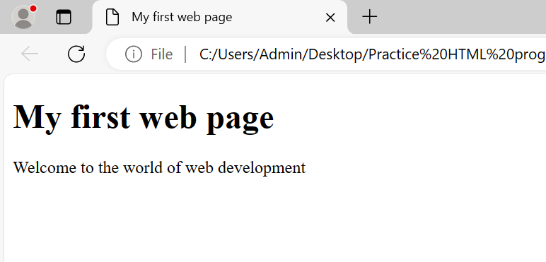

### **Exercise 2:**

HTML:

Create an HTML form with fields for the user's name, email, and a submit button.

CSS:

Style the form to have a centered layout, add some spacing between form elements, and apply different styles to the submit button.

**Program:**

**Userform.html(filename):**

<!DOCTYPE html>

<html lang="eng">

    <head>

        <meta charset="UTF-8">

        <meta name="viewport" content="width=device-width, initial-scale=1.0">

        <title>User form</title>

        <link rel="stylesheet" href="styles.css">

    </head>

    <body>

        <div class="container">

            <form action="#" method="post" class="user-form">

                <div class="form-group">

                    <label for="name">Name:</label>

                    <input type="text" id="name" name="name" required>

                </div>

                <div class="form-group">

                    <label for="email">Email:</label>

                    <input type="email" id="email" name="email" required>

                </div>

                <div class="form-group">

                    <button type="submit" class="submit-button">Submit</button>

                </div>

            </form>

        </div>

    </body>

</html>

**Styles.css(CSSfilename):**

body {

    font-family: Arial, sans-serif;

    margin: 0;

    padding: 0;

  }

  .container {

    display: flex;

    justify-content: center;

    align-items: center;

    height: 100vh;

  }

  .user-form {

    width: 300px;

    padding: 20px;

    border: 1px solid #ccc;

    border-radius: 8px;

  }

  .form-group {

    margin-bottom: 20px;

  }

  label {

    display: block;

    margin-bottom: 5px;

  }

  input[type="text"],

  input[type="email"] {

    width: 100%;

    padding: 10px;

    border: 1px solid #ccc;

    border-radius: 5px;

  }

  .submit-button {

    background-color: #007bff;

    color: #fff;

    padding: 10px 20px;

    border: none;

    border-radius: 5px;

    cursor: pointer;

  }

  .submit-button:hover {

    background-color: #0056b3;

  }

**Output:**

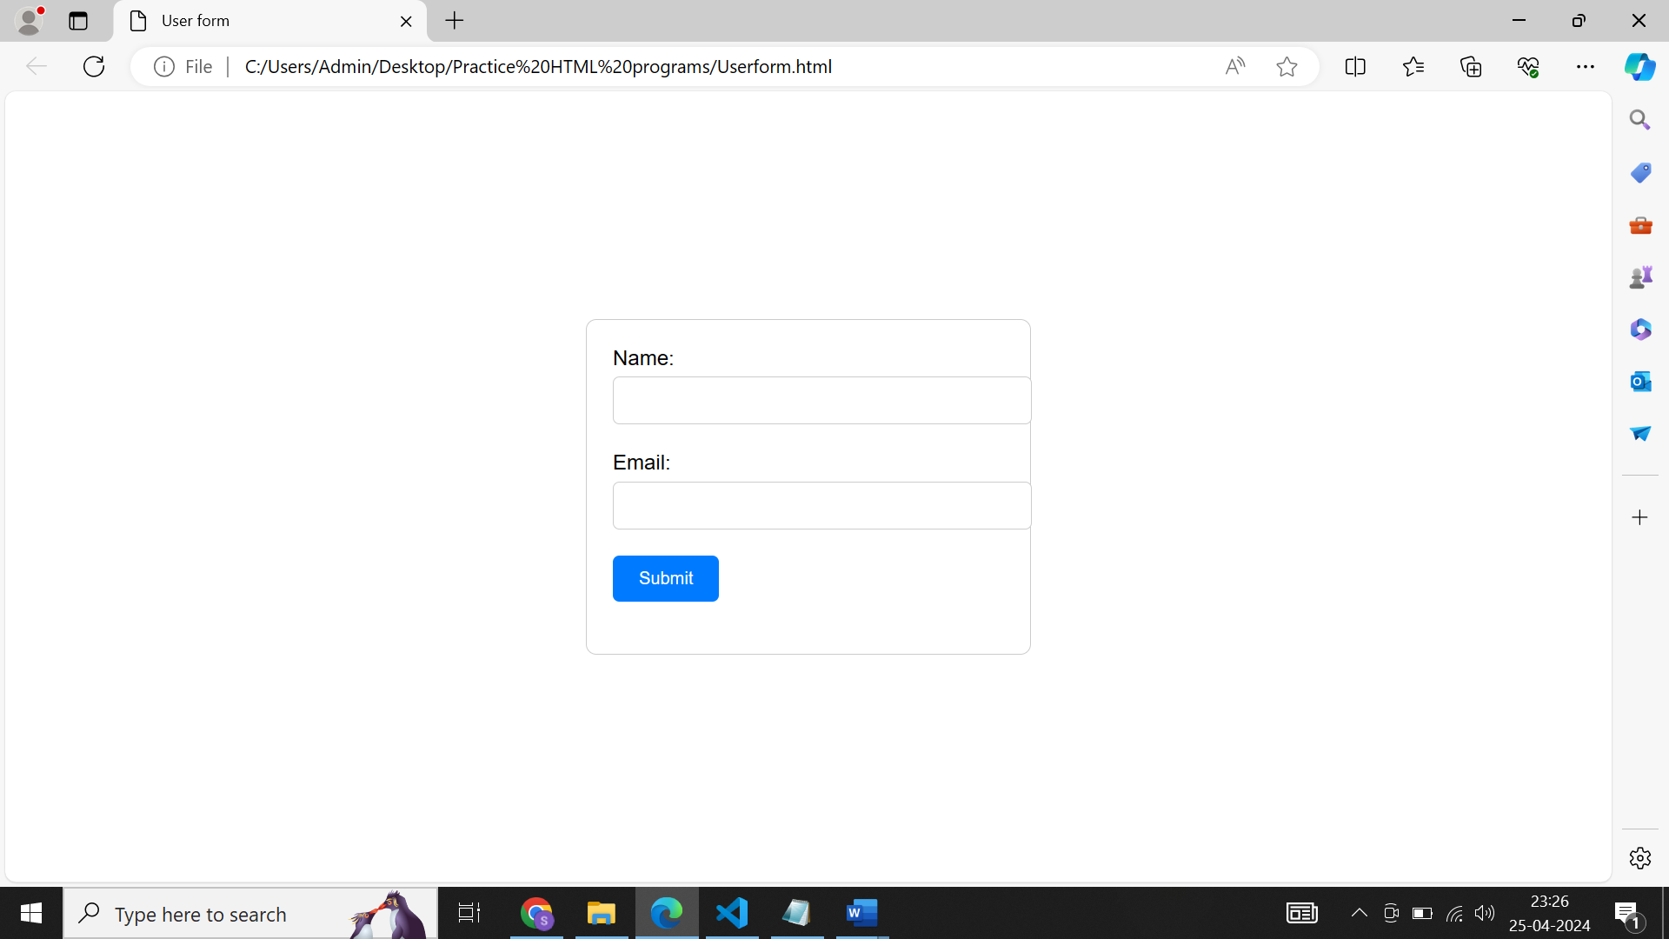

### **Exercise 3:**

HTML:

Create a navigation bar with three links - Home, About, and Contact.

CSS:

Style the navigation bar to have a background color, display the links horizontally, and add some

**Program:**

**Navigationbar.html(filename):**

<!DOCTYPE html>

<html lang="eng">

    <head>

        <meta charset="UTF-8">

        <meta name="viewport" content="width=device-width, initial-scale=1.0">

        <title>Navigation bar</title>

        <link rel="stylesheet" href="styles.css">

    </head>

    <body>

        <nav>

            <ul>

                <li><a href="#home">Home</a></li>

                <li><a href="#about">About</a></li>

                <li><a href="#contact">Contact</a></li>

            </ul>

        </nav>

    </body>

</html>

### **Styles.css(filename):**

nav {

    background-color: #333;

}

nav ul {

    list-style-type: none;

    margin: 0;

    padding: 0;

}

nav ul li {

    display: inline;

}

nav ul li a {

    display: inline-block;

    padding: 10px 20px;

    color: #fff;

    text-decoration: none;

}

nav ul li a:hover {

    background-color: #555;

}

**Output:**

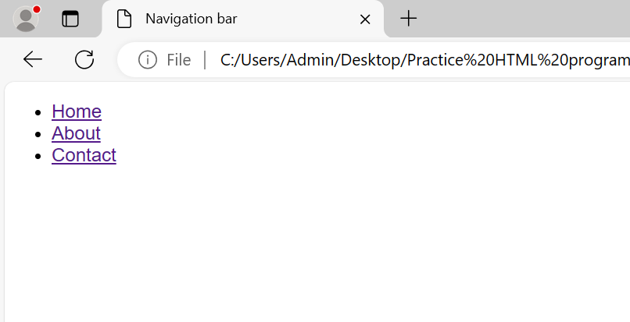

### **Exercise 4:**

HTML:

Create a simple HTML page with an image.

CSS:

Style the image to have a border, rounded corners, and a box shadow.

**Program:**

**Image.html(filename):**

<!DOCTYPE html>

<html lang="eng">

    <head>

        <meta charset="UTF-8">

        <meta name="viewport" content="width=device-width, initial-scale=1.0">

        <title>Creating an image</title>

        <link rel="stylesheet" href="Styles.css">

    </head>

    <body>

        <h1>Image</h1>

        <div class="image-container">

            <img src="HTML.jpg" alt="Image">

        </div>

    </body>

</html>

**Styles.css(filename):**

.image-container {

    display: inline-block;

    border: 2px solid #ca1290;

    border-radius: 10px;

    box-shadow: 0 0 10px orange;

}

.image-container img {

    display: block;

    max-width: 100%;

    height: auto;

}

**Output:**

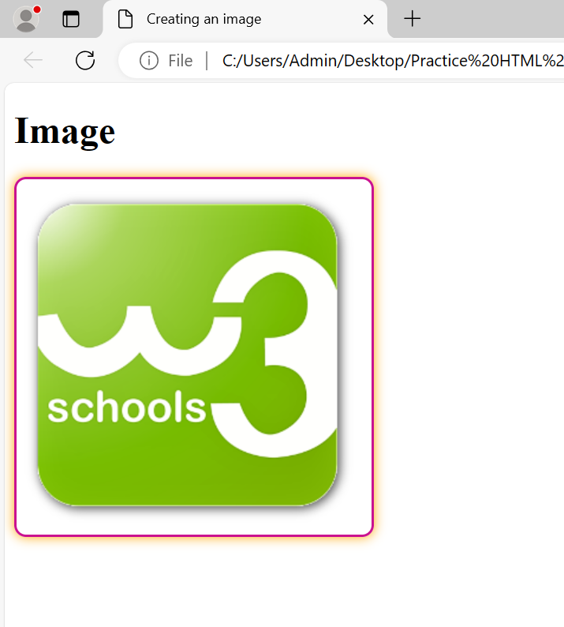

### **Exercise 5:**

HTML:

Create a two-column layout using div elements. Place some content in each column.

CSS:

Style the layout to have a fixed width, add background colors to each column, and apply some margin.

**Program:**

**Divelement.html(filename):**

<!DOCTYPE html>

<html lang="eng">

    <head>

        <meta charset="UTF-8">

        <meta name="viewport" content="width=device-width, initial-scale=1.0">

        <title>Two column layout</title>

        <link rel="stylesheet" href="Styles.css">

    </head>

    <body>

        <div class="container">

            <div class="column left">

                <h1>Greemus</h1>

                <p>Greemus Technologies is a customer oriented company.</p>

            </div>

            <div class="column right">

                <h1>Team name</h1>

                <p>ReactJS</p>

        </div>

    </body>

</html>

**Styles.css(filename):**

.container {

    width: 800px;

    margin: 0 auto;

    overflow: hidden;

}

.column {

    float: left;

    width: 50%;

    box-sizing: border-box;

    padding: 20px;

}

.left {

    background-color: #90d5f3;

}

.right {

    background-color: #e19fd1;

}

.clearfix::after {

    content: "";

    display: table;

    clear: both;

}

**Output:**

